System REQUIREMENTS SPECIFICATION
for
EcMS Operational reports

Release No 1.0 – Sept 2021

document identification no 3 char SYS ID/ DOC CODE /NN/ V M.n)  for details refer to document mgmt stds | document title | status  (draft/ RELEASED) | date of release | pages
eCMS /SRS/01/V1.0 | System Requirement Specifications For eCMS Operational reports | Draft | 21/09/2021 | 17

 | role in the project | Name | signature | date  (dd-mm-yy)
Authors | Technical Team | Santosh Subba
Reviewers | Project Lead | Sujit Patra
 |  | Karma
Approver | Project Manager | Raghavan Jaganathan

Endorsement by System Owner (internal)
 | Name | designation | signature | date  (dd-mm-yy)
Endorsed by System Owner | Chiew Lan Tan | Senior Director

release history
Release Number | associated change request number | Date (mm,yyyy) | Brief Summary of changes | Author
1.0 | First Release | 21/09/2021 |  | Santosh Subba

Table of Contents
1. Table of Contents 2
2. Introduction 4
2.1 References 4
2.2 Definitions and Abbreviations 4
3. Functional Requirements 5
3.1 OPERATIONAL Report OVERVIEW 5
3.2 Pre-Requisites and Assumptions 5
3.3 Operational report process flow 5
3.4 Use case diagram for Operational report 6
4. Operational Reports List 7
4.1 Number of applications Submitted 8
4.2 Number of Registration Submitted 8
4.3 Number of Manifest submitted 8
4.4 Summary of Declaration types submitted to customs 8
4.5 Total number of employees(user) 9
4.6 Total amount paid by tax types 9
4.7 Number of declarations made by a particular clearing agent 9
4.8 Expenses incurred to clear the goods from Kolkata 9
4.9 Details of goods cleared and dispatched from LTO. 10
4.10 Temporary Admission reconciliation report 10
4.11 Re-export reconciliation report 10
4.12 Bonded warehouse reconciliation report 11
4.13 warehouse reconciliation report 11
4.14 Refund Exemption Reconciliation Report 12
4.15 Total Number of Duty-Free Quota issued 13
4.16 Total number of customs officers by region and check post 13
4.17 summary of General exemptions 13
4.18 Number of Transactions under Authorized Compliant Trader (ACT) 13
4.19 Details of Goods stored in Each Warehouse 14
4.20 Details of Goods stored in the Temporary Storage 14
4.21 Number of Detention/Seizure/Confiscation (OFFENCE) 15

Introduction
This document defines & illustrates the Reports requirements, process flows as well as the detailed requirements of eCMS Operational Report module to be implemented for Department of Revenue and Customs, Bhutan.

References
The creation of the BECMS SRS was referenced using the following documents:
- FUNCATIONAL REQUIREMENT SPECIFICATION.docx
- TECHNICAL REQUIREMENT SPECIFICATION.docx
- Bhutan eCMS Technical Proposal TECH-3.pdf
- Bhutan eCMS Technical Proposal TECH-4.pdf
- Bhutan eCMS Technical Proposal TECH-5A.pdf
- Bhutan eCMS Technical Proposal TECH-5B.pdf
- Bhutan eCMS Technical Proposal TECH-6A.pdf
- Bhutan eCMS Technical Proposal TECH-6B.pdf

Definitions and Abbreviations
The table below lists the different acronyms and abbreviations as well as the definitions used throughout this SRS.
S/N | Abbreviations | Description
 | ACT | Authorized Compliant Trader
 | BITS | Bhutan Integrated Tax System
 | BTC | Bhutan Tariff Classification
 | CAB | Customs Act of Bhutan
 | CDS | Customs Declaration System
 | CFA | Clearing and Forwarding Agent
 | CID | Citizens Identification Number
 | CRRB | Customs Rules and Regulations of Bhutan
 | DRC | Department of Revenue & Customs
 | eCMS | Electronic Customs Management System
 | EMS | Express Mail Service
 | FRS | Functional Requirements Specification
 | GST | Goods and Services Tax
 | IDEC | Import Duty Exemption Certificate
 | LCS | Land Customs Station
 | LOG | Letter of Guarantee
 | LTO | Liaison and Transit Office
 | MIS | Management Information System
 | MoF | Ministry of Finance
 | Nu | Ngultrum
 | RGOB | Royal Government of Bhutan
 | RRCO | Regional Revenue and Customs Office
 | SAARC | South Asian Association for Regional Cooperation
 | SAD | Single Administration Document
 | SCTS | Single Customs Trade System
 | TPN | Taxpayer Number

Functional Requirements

OPERATIONAL Report OVERVIEW
Operational reporting is the process of regularly providing the complete report of an organization’s day to day activities and operations. These reports provide operational insights for time intervals like hourly, daily, weekly, and monthly. Serving various functions, these reports at times need to be customized for specific insights.
The operational reports will help the manger in identifying the areas that need attention and the ones that need to be tracked regularly.

Pre-Requisites and Assumptions
- User should have valid credential and able to access the Report in eCMS
- Operational report can be designed using the Jasper Report.
- Operational Reports date range should be less than or equal to 3 months of data.
- Operational report can send to the preview to see how the reports can looks when printed
- User should have able to download the report to pdf or excel format depend on user requirement.
- All the values and amounts in reports should be in NU.
- Input parameter of the start date and end date, by default is selected as current date.
- Others input parameter can be selected as all or particulars depend on user need.
- All financial data will be held in a minimum of 10.2(10 digit and 2 decimal digits) format or greater in alignment with international standard.

Operational report process flow

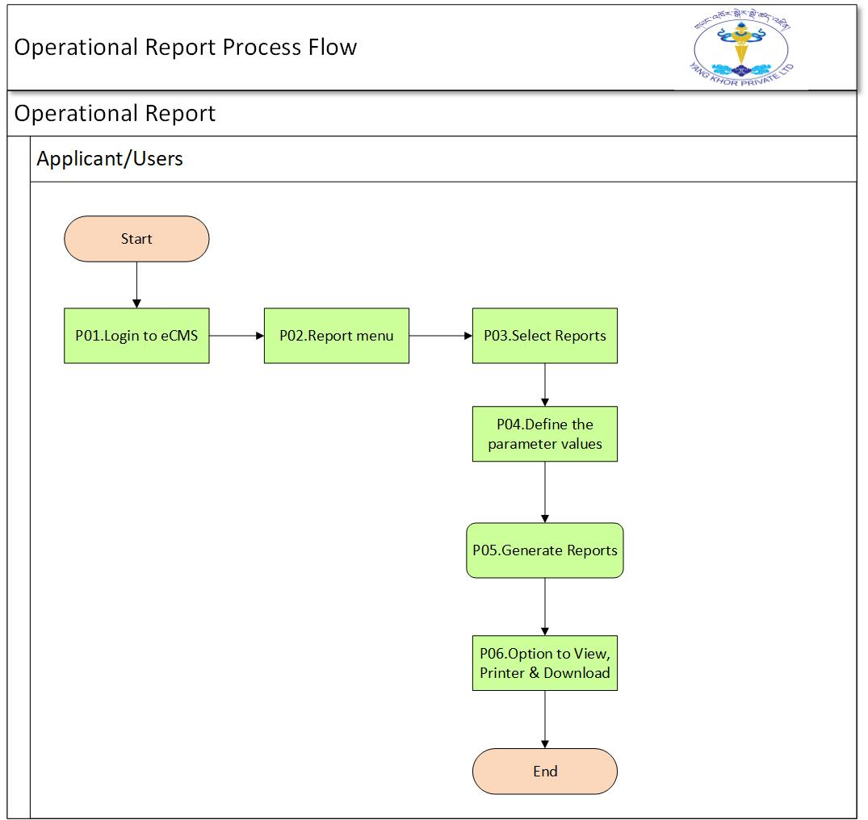

Process Steps
P01. Login to eCMS
Registered User can start and Login into eCMS system.
P02: Report menu
After accessing into the system, user can select the Report menu
P03: Select Reports
User can select which type of report he/she want to generate
P04: Select the Parameters
User can defined the parameters based on he/she required to printout
P05: Generate Report
Now User can also view the report before it print, to see whether report is in proper format or not.
P06: Option to View, printer and download
User can select the option to print or download to-Excel or PDF format.

Use case diagram for Operational report
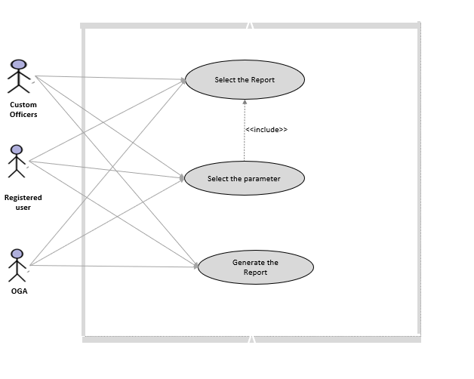

Operational Reports List
Following are the list of Operational Reports.

Sl.no | Report List | Parameters | User Group
 | Number of Application submitted | Start Date to end date, Type of applications | Customs
 | Number of Registration submitted | Start Date to end date, Type of Registrations | Customs
 | Number of Manifest Submitted | Start Date to end date, Type of Manifest: | Customs
 | Summary of Declaration Types Submitted to Customs | Start Date to end date, Types of Declaration: | Customs
 | Total Number of users registered | Start Date to end date, Types of Registered user: | Customs
 | Total Amount Paid by tax types | Start Date to end date, Customs office: | Customs
 | Number of declarations made by a particular clearing agent | Start Date to end date, Name of CFA /TPN of CFA: | Customs  Split report for customs and cfa/importer
 | Expenses incurred to clear the goods from Kolkata | Start Date to end date: | Customs
 | Details of goods cleared and dispatched from LTO | Start Date to end date, Customs office: | Customs
 | Temporary Admission reconciliation report | Start Date to end date, Importer: | Customs/CFA
 | Re-export reconciliation report | Start Date to end date, Importer: | Customs
 | Bonded Warehouse Reconciliation Report | Start Date to end date, Name of warehouse: | Customs
 | warehouse reconciliation report | Start Date to end date, Name of Warehouse | Customs
 | Refund Exemption reconciliation report | Start Date to end date: | Customs- refund section
 | Total Number of Duty-Free Quota issued | Start Date to end date, TPN: | HQ,
 | Total number of customs officers by region and check post | Start Date to end date, Customs office: | Customs (HQ,RRCOs)
 | Summary of General Exemptions | Start Date to end date, Types of Exemptions: | Customs
 | Number of Transactions under Authorize Compliance Trader (ACT) | Start Date to end date: | Customs
 | Details of Goods stored in Each warehouse | Start Date to end date, Warehouse No: | Customs
 | Details of goods stored in Temporary storage | Start Date to end date, Temp Storage No | Customs
 | Number of Detention/Seizure/Confiscation( Offence) | Start Date to end date, | Customs/

Number of applications Submitted
Input Parameters: Start Date: and End Date, Type of applications

Application type | Nos. of Apps Submitted | Approved | Total
ACT | 190 | 10 | 200
Import Duty Exemption | 120 | 30 | 150
Duty Free Quota | 120 | 50 | 170

Note: parameter application types (particular or all option)

Number of Registration Submitted
Input Parameters: Start Date: and End Date, Type of Registrations:

Registration type | No. of registered submitted | Approved | Total
CFA | 190 | 10 | 200
Warehouse | 120 | 30 | 150
Temporary Storage | 120 | 50 | 170
Declarant (CFA Employee) | 300 | 40 | 340
Trader | 70 | 30 | 100
OGA | 170 | 70 | 240

Note: parameter should be Registration type (particular or all option)

Number of Manifest submitted
Input Parameter: -Start Date to end date, Type of Manifest:
Manifest type | Nos. of manifest Submitted | Approved | Pending
Air cargo | 200 | 10 | 190
Road manifest | 150 | 30 | 120
Passenger manifest | 170 | 50 | 120
Dispatches (Goods Challan) | 370 | 0 | 370

Note: parameter manifest types (particular or all option)

Summary of Declaration types submitted to customs
Input Parameter: -Start Date to end date, Types of Declaration:
Type of Declaration | Total number of Declaration | Pending Approval | Approved | Paid | Release
Import | 200 | 10 | 100 | 200 | 90
Export | 100 | 10 | 60 | 00 | 30
Warehouse | 200 | 10 | 100 | 00 | 90
Transit | 200 | 10 | 100 | 00 | 90
Note: parameter declaration types (particular or all option)

Total number of employees(user)
Input parameter Start Date to end date, Types of Registered user
Users/Customs Office | Type of user reg | Nos. of users | Active | De-registered
HQ
 | CFA employee | 200 | 10 | 190
 | Custom officers | 50 | 20 | 30
 | Warehouse operator employee | 150 | 30 | 120
 | Temporary Storage operator employee | 170 | 50 | 120
 | Trader/Individuals | 100 | 30 | 70
 | OGA officers | 240 | 70 | 170
RRCO | Custom officers | 50 | 20 | 30
Note: parameter should be Register user types (particular or all option)

Total amount paid by tax types
Input Parameter Start Date to end date, Customs office:
Type of taxes | Total Collection | Total Exempted
Customs Duty (CD) | 2000 | 100
Goods & services Tax (GST) | 1500 | NA
Excise Equalization Tax (EET) | 1000 | NA
Green Tax (GT) | 6788 | NA
Fine & Penalties | 4566 | NA
Depot surcharge | 3245 | NA

Note: parameter custom office(particular), check post (particular or all option)

Number of declarations made by a particular clearing agent
Input parameter Start Date to end date, Name of CFA /TPN of CFA:
TPN of IMPORTER | Importer Name | Number of Declaration  Submitted | Total Number of Declaration  Cleared
BAB4567 | Dawa | 6000 | 5000
TAP9014 | Santosh | 200 | 200
BAP5667 | KARMA | 300 | 120

Note: parameter Name of CFA & TPN of CFA (particular). Merge Table CFA Name & TPN as one

Expenses incurred to clear the goods from Kolkata
Input parameter Start Date to end date:
International Transit Declaration no | International Transit Declaration Date | Amount | Tax type | Receipt Number | Receipt Date
ITD-102 | 7/9/2020 | 200 | EIC | 10281 | 12/12/2021
 | 7/9/2020 | 100 | EIC | 4566 | 12/12/2020
 | 7/9/2020 | 200 | EIC | 323 | 23/2/2020
 | 6/8/2020 | 300 | EIC | 456 | 4/5/2020

Note: tax type (handling charges/expenses incurred during clearance-EIC)

Details of goods cleared and dispatched from LTO.
Input Parameter Start Date to end date, Customs office:
Customs Office | Clearance done by | TPN | Importer Name | Arrival port | CIF value in Nu | Challan/AWB NO | Gross Weight(kg)
LTO Kalkata | CFA | PAB4567 | Karma | P/ling | 456788 | 56 | 5656
LTO Nepal | CFA | PAB7654 | Dawa | Samtse | 664747 | 8997 | 98876
LTO Kalkata | Customs | PAB9876 | Penjor | Gelephu | 554674 | 2331 | 67579

Note: parameter Customs office (Particular or all option)

Temporary Admission reconciliation report
Input Parameter Start Date to end date, Importer:-
ImporterTPN & Name | Temporary Declaration number | Child declaration number | Declaration Type | declaration TPN number | Importer Name | Original declaration quantity | Balance declaration quantity | declaration date
kcp1234  Jai Prakash | DEC1 |  | Temporary admission |  |  | 7 | 7 | 8/9/2021
 |  | DEC2 | Re-export |  |  | 3 | 4 | 9/9/2021
 |  | DEC3 | Transfer | Tcp123 | Hinduta | 2 | 2 | 10/9/2021
 |  | DEC4 | Re-export |  |  | 2 | 0 | 11/9/2021

Note: parameter Temp dec No (Particular or all option)

Re-export reconciliation report
Input Parameter Start Date to end date, Re-export Dec No:
declaration TPN number | Importer Name | Re-export Declaration number | Child declaration number | Declaration Type | Original declaration quantity | Balance declaration quantity | declaration date
kcp1234 |  | DEC1 |  | Temporary admission | 7 | 7 | 8/9/2021
 |  |  | DEC2 | Re-export | 3 | 4 | 9/9/2021
 |  |  | DEC3 | Re-export | 2 | 2 | 10/9/2021
 |  |  | DEC4 | Re-export | 2 | 0 | 11/9/2021

Note: parameter Re-export No (particular or all option)

Bonded warehouse reconciliation report
Input Parameter Start Date to end date, Name of warehouse:
warehouse Declaration number | Child declaration number | Declaration Type | declaration TPN number | Importer Name | Original declaration quantity | Balance declaration quantity | declaration date
DEC1 |  |  | kcp1234 |  | 7 | 7 | 8/9/2021
 | DEC2 | Ex-warehose | kcp1234 |  | 3 | 4 | 9/9/2021
 | DEC3 | transfer | kcp1234 |  | 2 | 2 | 10/9/2021
 | DEC4 |  | Kcp1234 |  | 2 | 0 | 11/9/2021
Note: parameter Warehouse TPN (particular or all options

warehouse reconciliation report
Input Parameter Start Date to end date, Name of warehouse:
Importer |  | Total Warehouse DeclNo
TPN | Name | Received | Released | Balance
KAP098765 -Karsel Dawa WareHouse
kcp1234 | A | 7 | 2 | 5
kcp1234 | XX | 3 | 3 | 0
kcp1234 | ZZ | 2 | 2 | 0
Kcp1234 | CC | 2 | 0 | 2
Note: parameter Warehouse TPN (particular or all options

Refund Exemption Reconciliation Report
Input Parameter Start Date to end date:
Exemption No: | Exemption date | Exempted Party TPN | Expt. party Name | Refund No. | Refund Date | Importer TPN | Importer Name | Dec No | BTC code | Dec. QTY | Exempted Qty | Declared value | Exempted Value | Receipt No | Receipt date | Total Refund Amount
312 | 2/03/2021 | BAB2345 | RBP | R10 | 2/3/2020 | BAB2345 | Karma | DEC234 | Apple | 3892 | 8793 | 30 | 20 | PG23 | 10/8/2021 | 500000
234 | 4/5/2020 | BAP7689 | MOE | R23 | 5/8/2021 | BAP6543 | Santosh | DEC23 | Orange | 879 | 879 | 20 | 10 | PG66 | 23/8/2020 | 390000
451 | 23/4/2021 | BAB5634 | DITT | R45 | 6/7/2021 | BAP3452 | Dawa | DEC567 | Papaya | 874 | 60 | 70 | 10 | PG53 | 6/9/2021 | 2345678

Total Number of Duty-Free Quota issued
Input Parameter Start Date to end date, TPN:..
Sl.no | TPN | TPN name | Approved date | Approved quota | Utilized quota | Balance quota
 | BAP7865 | Karma | 1/5/2020 | 200 | 50 | 150
 | BAP7654 | Sonam | 12/3/2020 | 30 | 20 | 10
 | BAP6578 | Dawa | 5/6/2021 | 40 | 40 | 0

Note: parameter TPN (particular or all option - dropdown)

Total number of customs officers by region and check post
Input Parameter Start Date to end date, Customs office:
Region Name (RRCO) | Customs station | Name of officers | Designation
Samste | Gomtu | Tandin wangdi | Joint Collector
 | Getu | Leki Penjor | Deputy Collector
 |  | Sonam Pelmo | Inspector

Note: parameter Customs officer (particular or all option - dropdown)

summary of General exemptions
Input Parameter Start Date to end date, Types of Exemptions:
Types of Exemption | Issued for | Exemption Category | Tax Types | Value
Personal effects | individual | Diplomat | EET | 200
 |  |  | GST | 800
 |  |  | CD | 10
Vehicle | Armed Force | Vehicle Quota | GT/EET/CD/GST | 200
Raw materials |  | Fiscal Incentive | EET/GST/CD | 500
Plant and machinery |  | Fiscal Incentive | CD/GST/EET | 30
Equipment |  | Multi/Bilateral agreement | CD/GST/EET | 40
Goods and Commodities |  | Others | CD/GST/EET | 670

Note: parameter types of Exemptions (particular or all option)
Text types 4 rows (GST/EET/CD/GT)

Number of Transactions under Authorized Compliant Trader (ACT)
Input Parameter Start Date to end date:
TPN | Party Name | Check post Name | Number of Declaration | Total Transaction Value
BAP2789 | Sangay | phuntsholing | 20 | 200000
BAP3421 | DawaEnterprise | Samtse | 50 | 50000
BAP6555 | Eight-11 | Gelephu | 600 | 780000

Details of Goods stored in Each Warehouse
Input Parameter Start Date to end date, Warehouse No:
Ware  house No. | Manifest | Item Description | MFST QTY | UOM | Admitted  Qty | Admitted  Date | Import  Declaration No | Dec.  Qty | Rele  ased  Qty | Qty To  Be  Rele  Ased | Released order No: | Released  Date
BWAO1 | MA201812 | Apple | 10 | NMB | 5 | 5/29/2018 | 2018DE1 | 5 | 5 | 0 | 234 | 5/29/2018
BWAO1 | MA201813 | Orange | 10 | KGM | 10 | 4/30/2019 | 2019DE2 | 10 | 10 | 0 | 6749 | 4/30/2019
BWAO1 | MA201814 | Pickle | 10 | KGM | 10 | 4/30/2019 | 2019DE3 | 10 | 10 | 0 | 654 | 4/30/2019
BWAO1 | MA201815 | Cloth | 10 | KGM | 10 | 4/30/2019 | 2019DE4 | 10 | 10 | 0 | 653 | 4/30/2019

Note: Note: parameter warehouse No: (particular or all options)

Details of Goods stored in the Temporary Storage
Input Parameter Start Date to end date, Temp Storage No:
Temp Storage No | Manifest | Item Desription | MFST QTY | UOM | Admitted qty | Admitted Date | Import  Declaration | Dec.  qty | Released  qty | Qty To  Be Released | Released order No: | Released Date
BTAO1 | MA20181 | Pure-bred  breeding animals | 10 | NMB | 5 | 1/1/2020 13:18 | 2018DE1 | 5 | 5 | 0 |  | 5/29/2018 18:58
BTAO1 | MA20182 | Sadsa | 10 | KGM | 10 | 4/30/2019 1:20 | 2019DE2 | 10 | 10 | 0 |  | 4/30/2019 3:40
BTAO1 | MA20183 | Sadsa | 10 | KGM | 10 | 4/30/2019 16:18 | 2019DE3 | 10 | 10 | 0 |  | 4/30/2019 16:33

Note: parameter temp storage No: (particular or all options)

Number of Detention/Seizure/Confiscation (OFFENCE)
Input Parameter: Start Date and End date, TPN

TPN | Name | Offence Type | Total No of offence | Total Value | Total Tax amount | Total Fines and penalties | Total Payable Amount | Remarks
BAP10289 | Santosh | seizure | 10 | 20000 | 1000 | 1000 | 2000
 |  | Confistcation | 2 | 2000 | 1000

Note: parameter TPN (particular or all options)

